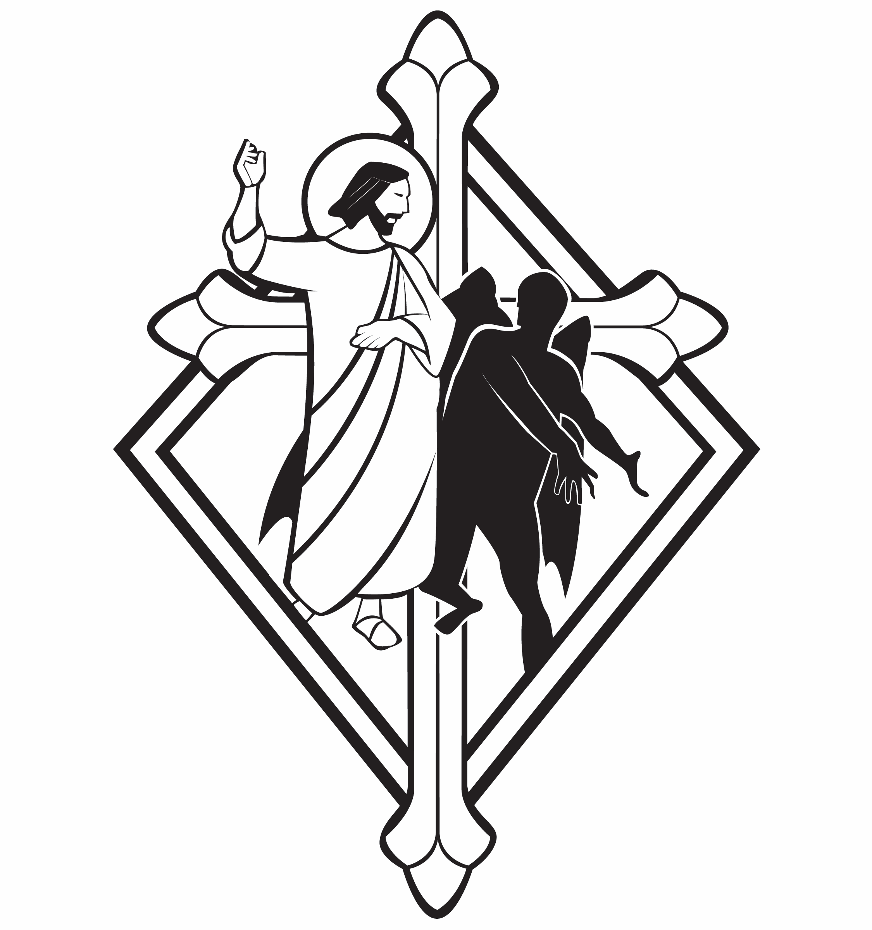
Epiphany Season

CHRIST LUTHERAN CHURCH | Lodi, California
January 28, 2024

WELCOME TO WORSHIP
Welcome to Christ Lutheran Church. We pray that your soul will be strengthened by the good news about God’s grace, love, and forgiveness given to us. If you would like to learn more about our church, please speak with our pastor or one of our members after the service.
- Bathrooms are located in the fellowship hall. A changing table is located in the women’s bathroom.
WORSHIP THEME
Christ comes as the great Prophet, foretold by Moses. But he does not come only as a man with a message. He comes as God in the flesh, the Holy One with power in his Word to make the devil flee. The people in Capernaum were amazed to see and hear Jesus. We worship one greater than Moses, who has driven out our sins, and has the power to drive out our doubts and fears.
The Common Service
The high and holy worship of God is faith in Jesus Christ. Such faith is created and sustained by God’s service to us (the German, “Gottesdienst,” “The Divine Service”). In the Divine Service, the Lord comes to us in His Word and Sacrament to bless and enliven us with His gifts. The Service is not something we do for God, but His service to us received in faith. The liturgy is God’s work. He gives, we receive.
HYMN A Mighty Fortress | CW 201
INVOCATION
M: In the name of the Father, and of the Son ✙ and of the Holy Spirit
C: Amen.
CONFESSION
M: Beloved in the Lord: let us draw near with a true heart and confess our sins to God our Father, asking him in the name of our Lord Jesus Christ to grant us forgiveness.
From God’s Word we know that wherever God puts His name, there He is to bless. In the Old Testament the temple was the place where God graciously caused His name to be present (1 Kings 8:27-30).
God has put His name —Father, Son, and Holy Spirit—on us in Holy Baptism. The Divine Service begins with the Invocation, the words spoken over us at our baptisms. Every Divine Service is for the hallowing of the Lord’s name, which the Small Catechism reminds us is done “when the Word of God is taught in its truth and purity, and we, as the children of God, also lead holy lives according to it” (Matthew 28:18-20).
C: Holy and merciful Father, I confess that I am by nature sinful, and that I have disobeyed you in my thoughts, words, and actions. I have done what is evil and failed to do what is good. For this I deserve your punishment both now and in eternity. But I am truly sorry for my sins, and trusting in my Savior Jesus Christ, I pray: Lord, have mercy on me, a sinner.
Lord, have mercy on us. Christ, have mercy on us. Lord, have mercy on us.

absolution
M: God, our heavenly Father, has been merciful to us and has given his only Son to be the atoning sacrifice for our sins. Therefore, as a called servant of Christ and by his authority, I forgive you all your sins in the name of the Father and of the Son ✙ and of the Holy Spirit.
C: Amen
M: In the peace of forgiveness, let us praise the Lord.
C: Glory be to God on high,
and on earth peace, good will toward men.
We praise you, we bless you, we worship you,
We glorify you, we give thanks to you, for your great glory.
O Lord God, heavenly King, God the Father almighty.
O Lord, the only begotten Son, Jesus Christ;
O Lord God, Lamb of God, Son of the Father,
You take away the sin of the world; have mercy on us.
You take away the sin of the world; receive our prayer.
You sit at the right hand of God the Father; have mercy on us.
For you only are holy; you only are the Lord.
You only, O Christ, with the Holy Spirit,
Are most high in the glory of God the Father. Amen.
PRAYER OF THE DAY
M: The Lord be with you.
C: And also with you.
M: Let us pray.
Lord God, you know that we are surrounded by many dangers and that we often stumble and fall. Strengthen us in body and mind, and bring us safely through all temptations; through Jesus Christ, your Son, our Lord, who lives and reigns with you and the Holy Spirit, one God, now and forever.
C: Amen
FIRST LESSON Deuteronomy 18:15–20
The fearful people asked for a prophet: one who would bring God’s word to them so that they would not hear the terrifying voice of the Lord. God provided that prophet in Moses, and prophesied one even greater.
¹⁵ The Lord your God will raise up for you a prophet like me from among you, from your fellow Israelites. You must listen to him. ¹⁶ For this is what you asked of the Lord your God at Horeb on the day of the assembly when you said, “Let us not hear the voice of the Lord our God nor see this great fire anymore, or we will die.”
¹⁷ The Lord said to me: “What they say is good. ¹⁸ I will raise up for them a prophet like you from among their fellow Israelites, and I will put my words in his mouth. He will tell them everything I command him. ¹⁹ I myself will call to account anyone who does not listen to my words that the prophet speaks in my name. ²⁰ But a prophet who presumes to speak in my name anything I have not commanded, or a prophet who speaks in the name of other gods, is to be put to death.”
PSALM Psalm 1, page 64
SECOND LESSON Hebrews 3:1–6
As great as Moses was, Christ is greater. He is faithful as the builder and steward of God’s house.
3 Therefore, holy brothers and sisters, who share in the heavenly calling, fix your thoughts on Jesus, whom we acknowledge as our apostle and high priest. ² He was faithful to the one who appointed him, just as Moses was faithful in all God’s house. ³ Jesus has been found worthy of greater honor than Moses, just as the builder of a house has greater honor than the house itself. ⁴ For every house is built by someone, but God is the builder of everything. ⁵ “Moses was faithful as a servant in all God’s house,” bearing witness to what would be spoken by God in the future. ⁶ But Christ is faithful as the Son over God’s house. And we are his house, if indeed we hold firmly to our confidence and the hope in which we glory.
VERSE OF THE DAY Isaiah 49:3
Alleluia. He said to me, “You are my servant in whom I will display my splendor.” Alleluia.
THE GOSPEL Mark 1:21–28
Christ came with authority and power to proclaim the gospel and free those under the power of the devil.
²¹ They went to Capernaum, and when the Sabbath came, Jesus went into the synagogue and began to teach. ²² The people were amazed at his teaching, because he taught them as one who had authority, not as the teachers of the law. ²³ Just then a man in their synagogue who was possessed by an impure spirit cried out, ²⁴ “What do you want with us, Jesus of Nazareth? Have you come to destroy us? I know who you are—the Holy One of God!”
²⁵ “Be quiet!” said Jesus sternly. “Come out of him!” ²⁶ The impure spirit shook the man violently and came out of him with a shriek.
²⁷ The people were all so amazed that they asked each other, “What is this? A new teaching—and with authority! He even gives orders to impure spirits and they obey him.” ²⁸ News about him spread quickly over the whole region of Galilee.

M This is the Gospel of the Lord.
C: Praise be to you, O Christ!
NICENE CREED
We believe in one God, Dt. 6:4
the Father, the Almighty, 2 Cor. 6:18
The Nicene Creed is the great Confession of the Christian faith professed by all Christians. The Creed originated at the First Council of Nicaea (c. AD. 325)
maker of heaven and earth, Is. 51:13
of all that is, seen and unseen. Col. 1:16
We believe in one Lord, Jesus Christ, 1 Cor 8:6
the only Son of God, Jn. 3:16
eternally begotten of the Father, Heb. 1:2,5
God from God, Light from Light, true God from true God, Jn. 1
begotten, not made, of one being with the Father. Jn. 10:30
Through him all things were made. Jn. 1:3
For us and for our salvation, 1 Th. 5:9
he came down from heaven, Jn. 6:38
was incarnate of the Holy Spirit and the virgin Mary, Lk. 1:35
and became fully human. Gal. 4:4

For our sake he was crucified under Pontius Pilate. Mk. 15:15
He suffered death and was buried. 1 Cor. 15:3-4a
The Creed itself was crafted as a confession of Scripture in opposition to the Arian heresy, which denied that the Lord Jesus and the Holy Spirit are God.

On the third day he rose again in accordance
with the Scriptures. 1 Cor. 15:4b
He ascended into heaven Ac. 2:33-34
and is seated at the right hand of the Father. Heb. 1:13
He will come again in glory Mt. 25:31
to judge the living and the dead, 2 Tim. 4:1
and his kingdom will have no end. Lk. 1:33
We believe in the Holy Spirit, the Lord, the giver of life, Job 33:4
who proceeds from the Father and the Son, Jn. 15:26
who in unity with the Father and the Son Jn. 4:24
is worshiped and glorified,
who has spoken through the prophets. 2 Pet. 1:25
We believe in one holy Christian Mt. 16:18; Eph. 2:19-20
and apostolic Church.
We acknowledge one baptism for the forgiveness of sins. Eph. 4:5; Ac. 2:38
We look for the resurrection of the dead 1 Cor. 15:21-22
and the life of the world to come. Amen. Rev. 22

HYMN OF THE DAY Songs of Thankfulness and Praise| CW 82
SERMON Mark 1

OFFERTORY
C: Create in me a clean heart, O God,
And renew a right spirit within me.
Cast me not away from your presence
And take not your Holy Spirit from me.
Restore unto me the joy of your salvation,
And uphold me with your free Spirit. Amen.

OFFERING
In response to God’s love and forgiveness, we give back a portion of what he has given us. The members of Christ Lutheran Church have joined to proclaim the gospel to this community. These offerings support that work. While our guests are welcome to participate, they should not feel obligated to do so.
PRAYER OF THE CHURCH
M: We give thanks to You, dear Father, for sending Your Son, Jesus Christ, into our flesh to preach the Gospel and cast out the works of Satan and the corruption of sin, which we could not overcome. By Your Word, rescue us from every evil of body and soul. Lord, in Your mercy,
C: Hear our prayer.
M: Lord of the Church, give joy to Your servants on whom You have laid the necessity to preach the Gospel, that many would be saved in every nation and that together we may share in the blessings of Christ. Lord, in Your mercy,
C: Hear our prayer.
M: Heavenly Father, give to all Christian homes the endurance that comes from Your Holy Spirit, that husbands and wives, parents and children may be disciplined and self-controlled in their duties, run their course in this life, and continue to the end in the holy Christian faith, ready to receive the imperishable wreath of eternal life. Lord, in Your mercy,
C: Hear our prayer.
M: Almighty God, Creator of the world and its foundations, You hold sway over the powers of nature and the rulers of the earth. Graciously preserve our land, its produce and industry, and our leaders together with our people. Do not disregard us for our sins, but renew us, that our lives may be peaceful and our country governed according to Your will. Lord, in Your mercy,
C: Hear our prayer.
M: O Lord, Your Son is the Great Physician of body and soul, at whose hand demon, disease and every ill must turn away. We bring before You those in any need [especially _____________]. Lord, in Your mercy,
C: Hear our prayer.

M: Holy Father, where there is forgiveness of sins, there is also life and salvation. Strengthen us against every spiritual attack of the devil, turn us in love toward our neighbor, and preserve us in body and soul to life everlasting. Lord, in Your mercy,
C: Hear our prayer.
M: Into Your hands, O Lord, we commend all for whom we pray, trusting in Your mercy; through Jesus Christ, our Lord. Amen
C: Amen.

LORD’S PRAYER Matthew 6:9-13; Luke 11:2-4
C: Our Father, who art in heaven,
hallowed be thy name,
thy kingdom come,
thy will be done on earth as it is in heaven.
Give us this day our daily bread;
and forgive us our trespasses,
as we forgive those
who trespass against us;
and lead us not into temptation,
but deliver us from evil.
For thine is the kingdom
and the power and the glory
forever and ever. Amen.

THE BLESSING
M: The Lord bless you and keep you.
The Lord make his face shine on you and be gracious to you.
The Lord look on you with favor and ✙ give you peace.
C: Amen.

CLOSING HYMN Praise the One Who Breaks the Darkness| CW 353

COPYRIGHT INFORMATION
Content requiring a copyright license is reproduced under OneLicense.net #A-718312. All rights reserved. The Common Service: Texts revised from The Lutheran Hymnal, 1941. Music revised by James Engel. Scripture Quotations: From the Holy Bible, New International Version (NIV 1984), © 1973, 1978, 1984 by Biblica, Inc.

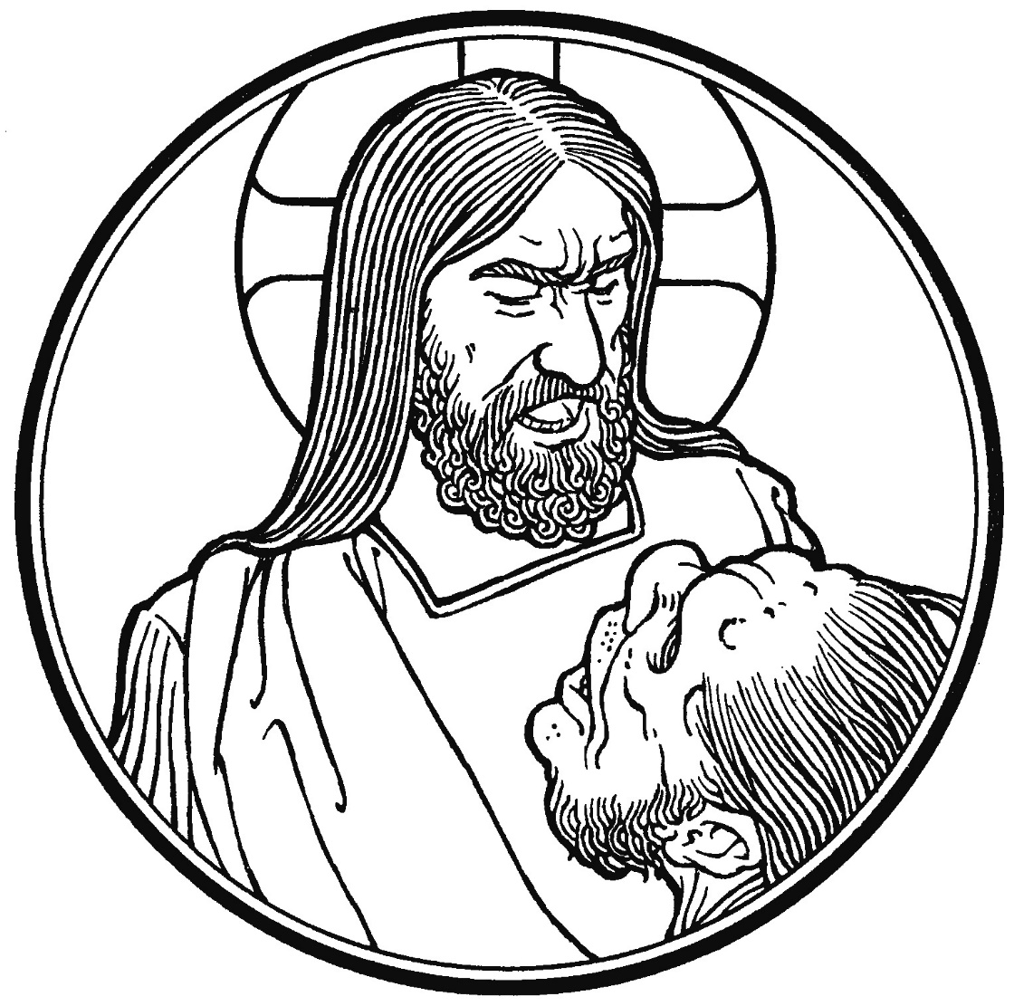

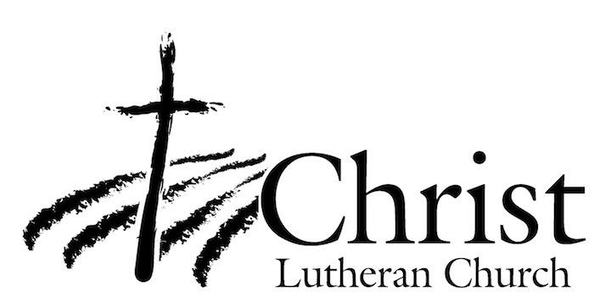
13009 N. Elderberry Ct.
Lodi, CA 95242
www.christlodi.org
209-368-6250
Pastor Timothy Leistekow
WELCOME TO CHRIST EV. LUTHERAN CHURCH!
We preach a message of forgiveness, hope and peace
through the death and resurrection of Jesus Christ.
Families and individuals of all ages will find opportunities
both to grow and to serve.
Our mission statement:
Look what Christ is doing!
He binds us together in fellowship
He gathers us in for worship
He builds us up for service
He sends us out with the gospel

“Now you are the body of Christ,
and each one of you is a part of it.”
(1 Corinthians 12:27)

